**Area Technical Documentation**

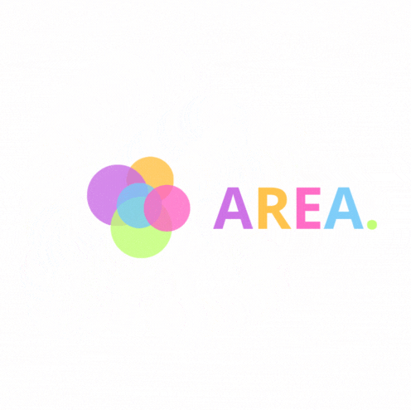

Summary

I. Project overview.

II. Project structure.

III. Architecture diagram.

IV. APIs used.

V. Server endpoints.

**I. Project overview.**

This is the technical documentation, it will detail all the technical parts and the code of the project. If you want to know how to use the application you are invited to read the provided user’s guide.

The AREA project consists in the creation of a software suite that functions similarly to IFTTT and/or Zapier. This software suite is a divided into 3 parts:

- A server to implement all the features.

- A web application to use the app from a browser.

- A mobile application to use the app from a phone

This project uses the following languages:

- Server → Nginx.

- Database → PostgreSql.

- Web application → VueJs.

- Mobile application → React Native.

  

**II. Project structure.**

The project is structured in 3 directories each one contains the code for the corresponding part: Front, Mobile and Server. The project is built using Docker, this will be detailed in a next section of the document.

**III. Architecture diagram.**

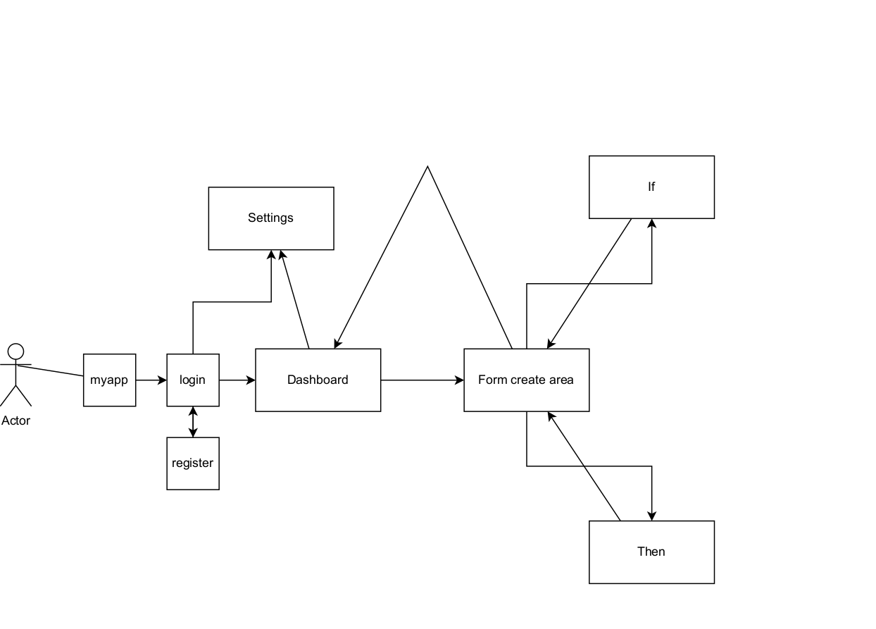

**V. Apis used.**

Here are the different APIs used for this project.

- Weather API (https://open-meteo.com/).

- Lol API (https://developer.riotgames.com/).

- Steam API (https://steamcommunity.com/dev?l=french).

- Discord API (<https://discord.com/developers/docs/intro>).

**VII. Server endpoints.**

